KAMPALA INTERNATIONAL UNIVERSITY IN TANZANIA [KIUT]

Title
THE IMPACT OF DECENTRALIZATION OF MEDICINE SUPPLY THROUGH MEDICAL STORES DEPARTMENT IN TANZANIA

Author
GOODLUCK MVUNGI
BPH/14724/501/DT

RESEARCH REPORT
Submitted in Partial Fulfillment of the Requirements for the Award of Bachelor Degree in Pharmacy at Kampala International University in Tanzania
Supervisor
Prof. R.S.Malele

August 2019,

DECLARATION
I, Goodluck Mvungi, declare that this dissertation report is my own original work and that it has not been presented and will not be presented to any other university for a similar or any other degree award.
Signature; ___________________________
Date; ___________________________

APPROVAL
I confirm that this Dissertation with a title of “The impact of decentralization of medicine supply through medical stores department in Tanzania” carried out under my supervision.

Name of supervisor
Prof. R. S. MALELE
Signature…………………………………..
Date……………………………………

COPY RIGHT©
This research work is a copyright material protected under the Berne Convention, the copyright Act 1999 and other international and national enactment, in that behalf, on international property. It may not be reproduced by any means in full or in part, except for short extracts in fair dealings, for research or private study, critically scholarly review or discourse with an acknowledgement, without the written permission of Kampala International University in Tanzania, on behalf of the author.

ACKNOWLEDGEMENTS
Glory is to the Almighty God who gave me power, health, strength, guidance and wisdom, to complete this work. Without his sincerely grace nothing would have been done. I would like to extend my gratitude and heartfelt appreciation to my major supervisor Prof. R.S Malele for his close supportive supervision and his useful constructive suggestions and recommendations during the whole period of my research study.
Special thanks to the Medical Stores Department staffs (MSD- HQ) in Dar es Salaam for their support and close supervision during the whole period my dissertation. This acknowledgement would be incomplete without special thanks to my family and close relatives & friends; Mr&Mrs Mvungi, my lovely brother (Chesco) and to my lovely sisters (Neema) for their moral love, spiritual support and abundantly blessings towards the whole period of my studies.
I also like to take this chance to show my appreciation to all the BPH (2015-2019) for their love and support during course-work period and towards the successful completion of my Bachelor of Pharmacy Studies.
Lastly, I wish to take this opportunity to extend my special thanks to my coordinate supervisors Dr. Kalala for encouragement and supportive efforts towards the accomplishment of this dissertation report.

DEDICATION
I dedicate this work to my mother Consolata Mvungi for her moral support and encouragement during the preparation of this research work. I would also wish to dedicate this work to my family for their love, prayer and encouragement towards the completion of this Program.

TABLE OF CONTENTS
DECLARATION i
APPROVAL ii
COPY RIGHT© iii
ACKNOWLEDGEMENTS v
DEDICATION vi
ABBREVIATIONS x
ABSTRACT xii
CHAPTER ONE 1
INTRODUCTION 1
1.1 Background of the Study 1
1.2 Statement of the Problem 2
1.3 Objectives of the Study 3
1.3.1 General Objective 3
1.3.2 Specific Objectives 3
1.4 Research questions 3
1.5 Rationale of the study 4
1.6 Scope of the Study 4
CHAPTER TWO LITERATURE REVIEW 5
2.0 Introduction 5
2.1 Definition of Terms 5
2.1.1 Supply Chain 5
2.1.2 Supply Chain Management (SCM) 5
2.1.3 Supply Chain Performance 5
2.1.4 Pharmaceutical Supply Chain (PSC) 5
2.2 Overview on Decentralization and Broader Reforms 6
2.3 Theoretical review 6
2.3.1 Decision space Framework 6
2.3.2 Transaction Cost Theory (TCT) 7
2.4 Structure of National Health & Pharmaceutical System 7
2.5 Pharmaceutical Services 8
2.6 Handling Equipment 9
2.7 Supply Chain Performance (SCP) 9
2.8 Inventory control system 10
2.8.1 The role of Inventory control on SCP 10
2.9 Conceptual Framework 11
CHAPTER THREE RESEARCH METHODOLOGY 13
3.0 Introduction 13
3.1 Research Design 13
3.2 The Study Area 13
3.3 The Target Population 13
3.4 Sample of the Study 13
Table 3.1 Study Sample Size 14
3.5 Data CollectionTools 14
3.6 Data Analysis 14
3.7 Ethical Consideration 14
3.8 Work Plan 15
3.10 Budget Estimation (In Tanzanian shillings) 15
CHAPTER FOUR 16
DATA ANALYSIS AND PRESENTATION OF FINDINGS 16
4.0 Introduction 16
4.1 Response Rate 16
4.2 The Respondents Characteristics 16
4.2.1 Respondents Gender 16
4.2.2 Respondents Age 17
4.2.3 Education Qualification 18
4.2.5 Working experience 19
4.3 Data Analysis for Variables 21
CHAPTER FIVE 22
CONCLUSION AND RECOMMENDATIONS 22
5.0 Introduction 22
5.2 Study Recommendation 23
5.3 Area for Further Research 23
REFERENCES 24
APPENDICES APPENDIX I: QUESTIONNAIRE 27

ABBREVIATIONS
AIDS: Acquired Immunodeficiency Syndrome
ARVs: Anti-retrovirals
C & F: Cost and Freight
CIF: Cost, Insurance, Freight
CIF: Cost Insurance and Freight
CPT: Carriage Paid To
DDP: Delivered Duty Unpaid
DDU: Delivered Duty Paid
EML: Essential Medicines List
FEFO: First Expiry first Out
FIFO: First In First Out
FOB: Free on Board Vessel
GDP: Gross domestic product
GOT: Government of Tanzania
HF: Health Facility
HIV: Human Immunodeficiency Virus
HTC: Hospital Therapeutic Committee
ILS: Integrated Logistics System
MoHCDGEC: Ministry of Health, Community Development, Gender, Elderly and Children
MSD: Medical Stores Department
NEDLIT: National Essential Drugs List for Tanzania
NEMLIT: National Essential Medicines List for Tanzania
NGO: Non-Governmental Organization
OI: Opportunistic Infection
PRTM: Pittiglio, Robin, Todd and McGrath(Management consulting firm)
PHF: Primary Health Facility
PORALG: Prime Minister’s Office Regional Administration and Local Government
PT: Pharmacy Technicians
SCP: Supply Chain Performance
TCT: Transaction Cost Theory
PSC: Pharmaceutical Supply Chain
SCM: supply chain management
IS: Information System
DS: Decision Space
NDP: National Drug Policy
SOP: Standard Operating Procedures
STG: Standard Treatment Guidelines
TMDA: Tanzania Medicine and Devices Authority
WHO: World Health Organization

ABSTRACT
The aim of this study was to determine factors influencing Performance in Pharmaceutical Supply Chain (PSC). A review of the literature showed that there are little empirical research studies conducted focusing on performance in PSC. This study aimed at filling the empirical gap and sheds light in Pharmaceutical supply chain in Tanzania. The study used exploratory design. The study was carried out in Dar es Salaam Region Medical Stores Department (MSD-HQs) and a sample of 65 staffs was drawn from a targeted population of 220. Data was collected using questionnaire instrument and subjected to Statistical Package for Social Science (SPSS v.23) for running the quantitative analysis technique. The testing of hypotheses was involved several data analysis techniques which included exploratory factor analysis (Kaiser-Meyer-Olkin Measure of Sampling Adequacy and Bartlett's Test of Sphericity), regression analysis (simple linear regression) and correlation analysis (Pearson correlation). The analyzed data was then presented in tables and figures for interpretation.
The study found that Information, Competence, Technological infrastructure and Inventory control are direct related and they have close relationship with performance in Pharmaceutical Supply Chain (PSC). Among the four factors tested, it was found that Quality of information significantly influences Performance in PSC.
This study has implication to various stakeholders and actors alongside pharmaceutical supply chain operations especially in Tanzania as well as the research community. The study recommends that actors alongside supply chain (manufacturers, suppliers, transport agencies, health facilities together with public and private beneficiaries.

Keywords: Performance Information, Competences, Technological infrastructure,Inventory Control and Pharmaceutical supply chain

CHAPTER ONE

INTRODUCTION

1.1 Background of the Study
Reforms in the public health sector in low and middle‐income countries (LMICs) have been the major policy focus over the last 4 decades. One of the components of the health sector reforms is decentralization. Decentralization is defined as the transfer of power and resources from the central government to agencies and actors at lower levels (Mills A, et al 1990). Denis Rondinelli proposed 3 forms of decentralization, namely deconcentrating, delegation, and devolution (Rondinelli D, 1981). Mills further refined these forms of decentralization to include privatization as a fourth form of decentralization.
While this categorization of decentralization has been widely discussed, in practice, countries may use a combination of models to meet their specific needs (Mills A, et al 1990).
In the health sector, decentralization and public services delivery continue to invite debate. On the one hand, there are scholars who see it as the panacea for reforming the health sector. They argue that decentralization brings services closer to the people (Regmi K, 2014), provide opportunity for community participation in planning and services delivery (De Vries MS, 2000) and improve quality, access, and equity(Saltman R, 2008). On the other hand, opponents argue that the health sector is complex and involves numerous functions and that greater local autonomy may undermine the performance of the health system (Homedes N, 2005).They also argue that decentralization local governments are less technically capable than the central government, and thus, decentralization may lead to the poor delivery of the services (Akin J, et al 2005).
Bossert11 argues that decentralization naturally grants decision‐making space to the local level authorities. Thedecision space is reflected in the different health system functional areas such as finance, human resources, service organization, access rules, and governance.7,11,12 Decision space is assessed by determining how much power for decision‐making on different functions such as planning and financial management is granted to local‐level authoritiesfrom the central government officially(Bossert T, 1998). However, in practice, decentralized officials may exercise a different degree of choice, which Bossert and Mitchelli refer to as de facto or informal decision space (Bossert TJ, 2007).
A few studies, however, have examined decision‐making space in the context of decentralization in LMICs on one specific functional area such as human resource capacity or financial management. For example, Marchal and Kegels18 assessed the availability of decision space on management and human resource capacities in Ghana. Tsofa et al (Tsofa B, et al 2017) examined how decentralization affects health sector planning and financial management in Kilifi County in Kenya and another study in the same country studied decentralization by devolution and its effects on health workforce and commodities management. (Tsofa B, et al 2017b). In Tanzania, only one study assessed decentralization and decision space in the decentralized district health system (Frumence G, et al 2013). There is, therefore, paucity of studies that analyze the amount of choices transferred from the central government to institutions at the decentralized health system in Tanzania.

1.2 Statement of the Problem
Pharmaceutical supply chain is very complex in nature, since pharmaceuticals are vital products due to the fact that their availability and accessibility are critical for government, companies and citizen. Then, it is crucial that medicine and pharmaceutical equipment has to be delivered at the right time to the right place in standard conditions. Improper distribution of medicine, not only affects companies‟ reputation, costumer’s satisfaction and companies‟ profit, but also could disturb the healing processes of patients and affect total productivity of the nation (Yousefi & Alibabaei, 2015). Information plays a virtual role in supply chain and hence allows company to gain competitive advantage (Yousefi & Alibabaei, 2015).
Sharing and management of Information is necessary for coordination and collaboration among supply chain partners and hence it reduces supply chain risks (Abldullah & Rayamah, 2017). An information system (IS) has a significant role in managing and integrating data within the supply chain. Adequate information flow is one of the most important aspects in supply chain operations together with the entire performance (Yousefi & Alibabaei, 2015). In reference to the study of Sangari et al. (2015) on the impact of knowledge management processes on supply chain performance, they found that knowledge management processes have a significant impact and influence towards Supply chain performance. Companies must identify critical competences that can drive performance of the organization (Meyer et al., 2015).
Technology has strongly evidence in high clock-speed in pharmaceutical supply chain through the use of Information systems, Barcode system, RFID, manual and mechanical handling equipment‟s (MacCarthy et al., 2016). Inventory is an area of hospital supply chain management that particularly warrants close study, since inventory value for pharmaceutical supply chain is much higher compared to other chain due to life – saving interest (Nyaga & Kihara, 2017). But, many scholars and practitioners focus a great deal of attention toward economic and environmental sustainability in supply chains, less attention is paid to supply chain performance (Themisticleous et al., 2004), (Khan et al., 2015), (Anand& Grover, 2015) and (Mani et al., 2016).
However, limited research is available in the area of performance in pharmaceutical supply chain (Singh et al., 2016). Since PSC is complex in nature and has a greatest effect on health and national matters, this research aims at shading a light and provides insights in PSC and to fill the gaps on the impact of decentralization of the country medicine supply management systems and also the financial flows for essential medicines and medical supplies in Tanzania.

1.3 Objectives of the Study

1.3.1 General Objective
The general objective of this study is to carry out an in-depth assessment of the impact of decentralization of the country medicine supply management systems and also the financial flows for essential medicines and medical supplies in Tanzania a case study focus at MSD in Tanzania.

1.3.2 Specific Objectives
Specific objectives are:
- To assess medicines financing and financial flows for the existing systems for procurement and distribution of essential Medicines
- To examine the effect of technological infrastructure on the decentralized pharmaceutical supply chain.
- To determine the status of public health service delivery as a result of decentralization in Tanzania
- To analyze the challenges affecting decentralization for improved public health service delivery in Tanzania.
- To determine the effect of inventory control on performance of Decentralized pharmaceutical supply chain

1.4 Research questions
The study aimed to answer five research questions;
- How do the medicines financing and financial flow for the existing systems for procurement and distribution of essential Medicines?
- What are the effects of technological infrastructure on performance of pharmaceutical supply chain?
- To what extent has decentralization affected public health service delivery in Tanzania?
- What challenges constrain implementation of decentralization for improved public health service delivery in Tanzania?
- What are the effects of inventory control on performance of pharmaceutical supply chain?

1.5 Rationale of the study
The increase of scope of activities within the past few years has seen an increase in the number of partners involved in the procurement and supply management of essential medicines.
This research aims to advance the impact of decentralization and knowledge in supply chain performance specifically in Public sector organization. The theoretical and practical contributions of this research can be summarized in as follows. After completion of this study, actors alongside different supply chains (individuals, organization and companies) will be able to understand critical factors that are likely to influence performance in Pharmaceutical Supply Chain (PSC). Moreover, the study may be used as an influence towards achieving market competitive of a company products and services. Also the recommendations of the study provide a meant to help supply chain actors to understand their role in improving performance in supply chain. However, the result of this study expects to contribute knowledge to the Medical Stores Department (MSD) organization in matters relating to performance as well as the Ministry of Health, Community Development, Gender, Elderly and Children (MoHCDGEC).
It is through this background that Tanzania decided to do an in-depth assessment of procurement and decentralized supply management system as well as mapping of the partner’s coordination within the procurement and supply management system.

1.6 Scope of the Study
The study focuses on decentralization and its effectiveness on Essential Medicine supply in Tanzania through MSD in Dar es Salaam Region. The selected cases for the study are among the government organizational structural levels that have implemented decentralization reforms and affected by the 14 policy actions since 2000. The study intends to assess whether decentralization has resulted in outcomes that meet the expectations of the policy and the public (citizens) in response to the decentralisation policy objective of improving public health service delivery in terms of access, quantity, quality and its sub sequent management.

CHAPTER TWO
LITERATURE REVIEW

2.0 Introduction
The chapter consists of the definition of terms, theoretical base of the study, empirical literature review, supply chain performance models, current issues in supply chain management and conceptual framework.

2.1 Definition of Terms
This section covers definition of terms where by key terms that relate to the study concept will be defined.

2.1.1 Supply Chain
Supply chain means all inter-linked resources and activities needed to create and deliver products and services to customer (Mwangi&Kagiri, 2016).

2.1.2 Supply Chain Management (SCM)
SCM is a process of integrating /utilizing suppliers, manufacturers, warehouses and retailers, so that goods are produced and delivered at the right quantities and at the right time, while minimizing costs as well as satisfying customer requirement (Bahari et al., 2017).

2.1.3 Supply Chain Performance
Supply Chain Performance (SCP) refers to the systematic process of measuring the effectiveness and efficiency of Supply Chain operations (Anand& Grover, 2015). The term also refer to the extended supply chains activities in meeting end-customer requirements, including product availability, on-time delivery, and all necessary inventory and capacity in supply chain to deliver that performance in a responsive manner (Nurmandi& Kim, 2017).

2.1.4 Pharmaceutical Supply Chain (PSC)
Pharmaceutical Supply Chain (PSC) is the means by which prescribed medicines and medical equipments are distributed to health facilities and patients (Parmata et al., 2016). Drugs are manufactured at manufacturing promises, transported to Medical Stores Department (MSD) distributed to health facilities (hospitals, dispensary, health centers and pharmacies) and eventually provided to end user consumer.

2.2 Overview on Decentralization and Broader Reforms
Decentralization has been conceptualized in a variety of ways by different authors. Crook and Manor (1998) and Agrawal and Ribot (1999) define it as the transfer of powers from central government to lower levels in a political, administrative and territorial hierarchy. Faguet (1997) defines decentralization as the devolution of all specific functions with all of the administrative, economic and political attributes by the central government to local governments. The later are independent of the centre and sovereign within a legally defined geographic area.
UNDP (1997) refers to decentralization, as the restructuring or reorganization of authority so that there is a system of co-responsibility between institutions of governance at the central, regional and local levels according to the subsidiary principle of increasing the overall quality and effectiveness of the system of governance while increasing the authority and capacities at sub-national levels.
The history on reforming public institutions has been a matter of concern by many governments in both developed and developing nations. The thrust has been to improve service delivery. It is worth to note that embarking in reforming public sector institutions and public administration as a machinery is a complex and cumbersome process that requires political will and management support of the highest level (Corkey, 1998). It further acknowledge that, the more comprehensive the reforms are, the more complex they become hence the greater the management efforts and confidence needed to yield positive results and success (ibid). Mutahaba and Kiragu (2006) opined that for a country that embarks on public service reforms requires massive expertise, skilled workforce with requisite technical skills and other resources. In addition, such reforms should consider the prevailing policies, structures, systems, human and financial resource viability.

2.3 Theoretical review

2.3.1 Decision space Framework
This study is guided by the decision space framework which was developed by Thomas Bossert (1998). The decision space framework (DSF) is based on a modified principal‐agent approach. The principal‐agent theory conceptualizes a “principal” with specific objectives and “agents” who are charged with the responsibilities of implementing those objectives (Pratt J, 1991)
In this study, the principal refers to the Ministry of Health, Community Development, Gender and Elderly and the President's Office Regional Administration Local Government. The agents refer to the decentralized local government authorities, particularly the district health managers. Other notable government agencies at the national level which influence decision‐making in Tanzania are the Public Services Commission and the Ministry of Finance and Economic
Affairs. As indicated in Table 1, the decision space (DS) was determined by assessing the involvement of the respondents and central level authorities in local decisions.
TABLE 1 Assessment of decision space in decentralized planning and financial resources
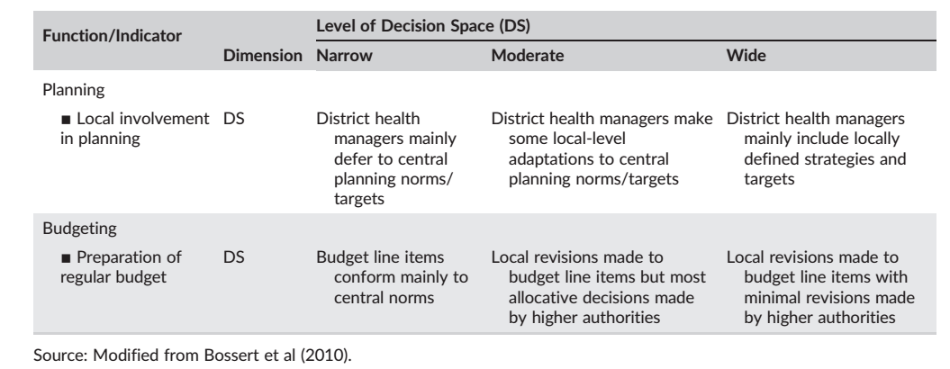

2.3.2 Transaction Cost Theory (TCT)
According to Manzouri and Rahman (2013), Transaction cost theory is grouped under inter-organization category, TCT states the inter-organizational transactions, they are not only focused on transaction costs but also focused on total costs either in purchasing or selling the products. The theory was developed to facilitate an analysis of comparative cost adapting, planning and monitoring of task completion under alternative governance structures (Suleiman, 2015). The theory supports the independent variable (technological infrastructure and inventory) by confirming the importance of viewing costs as important aspect in an organization and how it can affect the performance of supply chain. The combination of different costs from different level of supply chain will be subjected to this theory.

2.4 Structure of National Health & Pharmaceutical System
The health system in Tanzania has two major components; the public and the private sector. The public share is 56%; the private share is 44% (which includes Faith Based Organizations (NGOs) 30% and private for profit 14 %) (Ministry of Health and Social Welfare in Tanzania, 2008).
The system works at four levels; the community, the ward where there is a dispensary and a health centre at the division level. As one moves further there is the district and regional hospitals at district and regional levels respectively.
At the zonal and national levels, are the consultant/referral hospitals (MOHSW, 2007) Community Health post, ADDO 2-5,000 Currently in Tanzania there are a total of 5,379 health facilities geographically distributed so that 70% of the population is within 5 km of a facility and 90% is within 10 km as at the end of 2005 (MOH&SW, 2008). Administratively, the health system is largely decentralized. The MoHSW has direct responsibility for the referral and regional hospitals, and regulatory power over all health facilities. The district facilities are independently run by the Prime Minister’s Office Regional Administration and Local Government(PORALG).

2.5 Pharmaceutical Services
In improving the Pharmaceutical sector, the government endorsed the first National Drug Policy, the Standard Treatment Guidelines (STG) and the National Essential Medicine List for Tanzania (NEMLIT) in 1991. The STG and NEMLIT were later revised in 1997. These documents are crucial in medicine quantification, procurement and supply to achieve therapeutically better outcomes to the patients, a most important objective of all health care systems.
The overall objectives of the NDP are to make available to all Tanzanians at all times safe, efficacious and quality essential medicines at affordable price to an individual and the community, when these are needed to prevent, cure or reduce illness and suffering. The NDP set up a master plan for Pharmaceutical sector to further improve the sector between 1992 and 2000, with clear objectives, strategies, time frame and budget required to achieve development in key areas of the pharmaceutical sector. It provides a framework to coordinate activities by the various actors in the pharmaceutical sector: the public, private and mission sectors, donors and other interested parties. Implementation of the NDP Pharmaceutical Master plan is coordinated by the Pharmaceutical Services Unit (PSU) at Ministry of Health (MOH&SW, 2008).
Some of the key roles of the PSU are to ensure that MSD performs according to the MSD Act of 1993,to ensure that adequate funds to procure drugs and medical supplies are provided to MSD, to assist health facilities with capacity to quantify drugs requirements, to establish effective strategies for improving rational drugs use, to in collaboration with TFDA ensure the quality of medicines, to establish effective drug management and monitoring systems at health facility level and reduce drug waste and pilferage and to ensure an appropriate allocation of resources to health facilities for drugs that takes into account equity, patient load, morbidity and drug needs(MOH&SW,2008).
Provision of medicines and medical supplies in Tanzania is through the public nonfor-profit system (56%) and private-for-profit sector (44%)(MOH&SW, 2008). All public facilities receive their supply shares by either using allocated financial budgets or draw supplies for use against established budget ceilings. The total medicine budget disbursed for the public sector for the year 2000, 2001 and 2002 and 2007 in US$ was 14.1million, 16.2 million, 18.3 million, 28.5million respectively. The budget for year 2007/08 was US$ 28.46 million. Although the budget has been increasing every year this however is not enough to meet the national medicine needs.
The Tanzania Food and Drugs Authority (TFDA) is responsible for the regulation of medicines and conducts inspections of the private and public drugs outlets in Tanzania. Tanzania has about 640 registered Pharmacists, 352 Pharmacy Technicians (PT) and 312 Pharmacy Assistants.3 The Pharmacy Council is responsible for regulating the pharmacy profession and for registering the pharmaceutical personnel in the country (MOH&SW, 2008).

2.6 Handling Equipment
Technological tools lower coordination cost, and improve transactional efficiency through increased information sharing resulting in improved SCP (Kanda &Iravo, 2015). In pharmaceutical supply chains, the influence of technology has strongly evident in high clock-speed through the use of advances technologies in supporting supply chain operations (MacCarthy et al., 2016). 19 In reference to the study of Lin (2007), on supply chain performance (SCP) and adoption of new technologies for logistics services in Taiwan, they present a list of technologies that are likely to influence SCP; data acquisition technologies, information technologies, warehouse technologies and transport technologies. They found that adoption of new logistic technologies has positive impact on supply chain performance. Modern organizational landscape includes hardware, networking and bandwidth, through the use of material handling equipment; organization is likely to acquire the following benefits; improve efficiency, cut down costs, maximize space utilization, minimize accidents in workplace and improve customer service (Islam et al., 2015).

2.7 Supply Chain Performance (SCP)
SCP is defined as a systematic process of measuring the effectiveness and efficiency of supply chain operations (Sundram et al., 2016). Supply chain performance refers to the evaluation of supply chain management, and includes both tangible and intangible factors. Tangible factor may include cost while intangible factor may include capacity utilization (Chang et al., 2013). Supply chain performance may be seen as an important indicator of how well supply chain strategy fulfills its objectives and goals (Rana et al., 2015). For a company to be successful and take a competitive edge in the market it must have a strategic fit. Strategic fit is the state where by competitive strategies of a firm aligns with the supply chain strategies (Sambasivan& Jacob, 2008).
PRTM was the first universal performance measures that were generated by Pittiglio, Rabin, Todd and McGrant to measure performance of supply chain. Globalization and technological effects has lead the growing need for both supply chain actors and environmental concern and measurement criteria’s in supply chain has been subjected to the light (Gopal & Thakkar, 2012).
According to the study conducted by Carr (2016), on the relationship among information technology, organizational cooperation and supply chain performance. The results reveal that quality; cost and delivery are the most common outcome of supply chain performance. SCOR model can be useful in understanding and managing the interaction between suppliers, customers and distributors in terms of planning, sourcing, making and delivery of products McLaughlin et., al. (2003). Performance constructs include cost, quality, responsiveness, flexibility, delivery, inventory, process involvement, innovation and sale. While, most popular supply chain performance metrics include cost, reliability, quality and responsiveness (Zhang, 2012). Sangwa and Sangwan (2018) in performance study identify key performance indicators (KPI‟s) in supply chain; Customer service, customer retention rate, annual customer complaints, responsiveness, customer involvement, on time delivery and service quality (Sangwa&Sangwan, 2018).

2.8 Inventory control system
According to Yusuf (2003), inventory control system improves performance of supply chain through reduction or elimination of pilferage, elimination of the delivery and avoidance in holding slow moving items. Base stock system and reorder point level are common models used in management and control of inventory in retailer industry (Salam et al., 2016).

2.8.1 The role of Inventory control on SCP
Inventory represents the biggest numbers in an organization balance sheet (Barwa, 2015). Inventory control is a close control over the flow of goods or materials into inventory and preventing loss by ensuring that adequate inventory levels are maintained. For a company to maximize service level in retail industry, it must maintain minimum inventory level (Yusuf, 2003). Demand variability has been found as the most significant influence on the level of inventory to keep. Inventory management of an organization should ensure that asset, stocks and other supplies are kept at level that provide maximum return and service level at the possible minimum cost (Salam et al., 2016).
Control is a process by which events are made to conform to a plan (Yusuf, 2003). According to the study conducted by Martin and Patteson (2009) on measuring company performance and supply chain, they found that inventory control and cycle time are the most significant metrics in measuring supply chain performance of an organization. Inventory control and cycle time are the most significant metrics in measuring supply chain performance of an organization (Martin & Patterson, 2009). Study conducted by Singh et al. (2016), on addressing strategic issues in pharmaceutical supply chain by linking resource, process and performance. They proposed a list of pharmaceutical supply chain processes; Inventory management, Outsource logistic activities, Reverse logistics, Lean manufacturing, Quality management and Green supply chain management. 20 The most common metrics used by practitioners in measuring supply chain performance include; quality, delivery, cost, price and flexibility (Loice et al., 2017).
The primary concern of management on control of inventory is to retain stock at appropriate levels, safeguard of assets, ensuring that stocks are properly used by organization and proper stock accounting (Yusuf, 2003).

2.9 Conceptual Framework
This section presents factors that can influence supply chain performance from which the analysis of the study will be made. Dependent variable of the study is performance of pharmaceutical supply chain, which is influenced by Independent variables; Information, Employee Competences, Technological infrastructure and Inventory control.

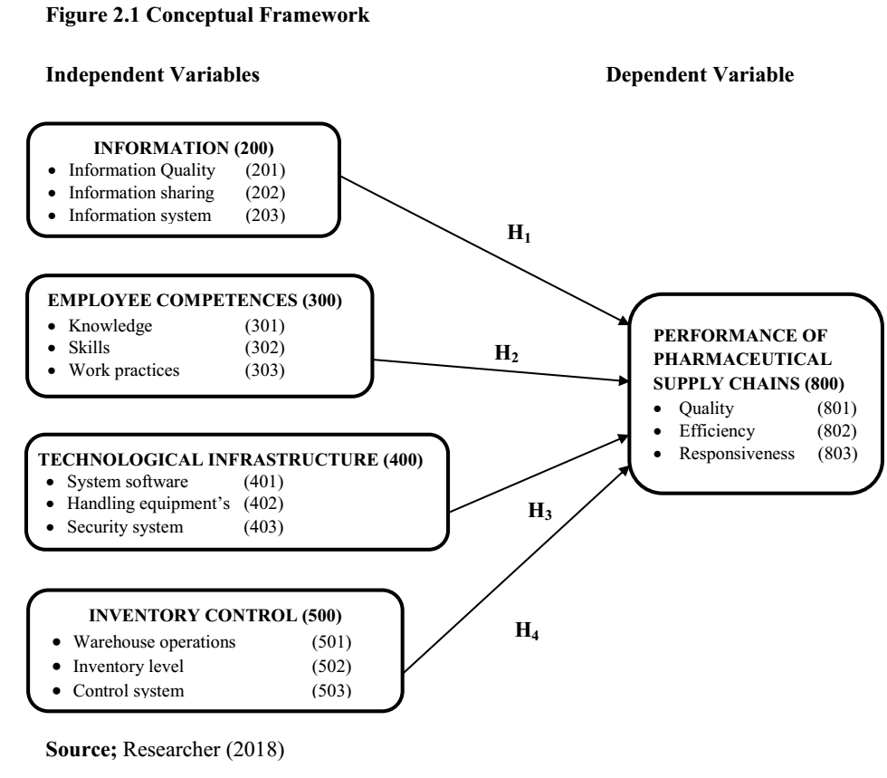

CHAPTER THREE
RESEARCH METHODOLOGY

3.0 Introduction
This chapter is divided into the following sections; research design, area of the study, population, sample size, sampling procedures together with data collection methods and data analysis techniques.

3.1 Research Design
The researcher confirms this study to be a case designed study and therefore employed exploratory design in order to find underlying relationship between factors and performance attributes. Exploratory design is stated as technique used to explore causal relationship between variables while descriptive design aims at describing the phenomena (Kothari, 2004).

3.2 The Study Area
The study was conducted at the Medicals Stores Department (MSD) organization in Dar es Salaam region. The rationale of selecting MSD is because is the only public Organization dealing with medical supplies in Tanzania.

3.3 The Target Population
The study targeted MSD staffs located in different departments and sections that are directly linked with pharmaceutical supply chain located in Dar es Salaam region. Unit of analysis for this study was the staffs and officers in Medical Store Department (MSD Head Quarters).

3.4 Sample of the Study
This research used 30% (65 participants) as a sample for this study. A 30% (65 participants) of a total population is said to be the minimum acceptable for sample size computation in a given study (Mugenda, 2008). The researcher used a total of 65 samples from total targeted population of 220 elements. The figure 3.1 below shows the distribution of samples.

Table 3.1 Study Sample Size
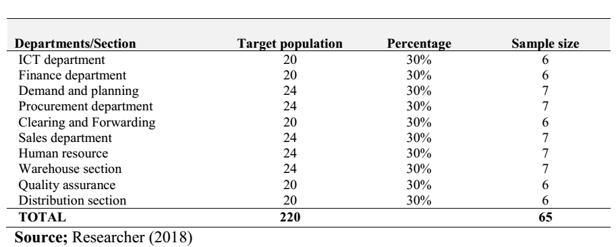

3.5 Data Collection Tools
The researcher used questionnaire instrument in gathering/collecting the required data. List of coded questions item was developed based in variable nature (conceptual framework). The intended respondents were required to read, understand and fill/write the question items based on Likert scale.

3.6 Data Analysis
Quantitative methods of data analysis were used in analyzing the data for this study. Data classifications was done on the basis of common characteristic with the help of Statistical Package for Scientific Studies (SPSS – V.23).

3.7 Ethical Consideration
The study was conscious on ethical issues. Hence, measures were taken to ensure that morals and ethics issues are adhered to. Research permits from the Government Authorities was obtained before embarking on the field for data collection. The clearance letter from The Kampala International University of Tanzania introduced the Executive Director of the selected MSD requesting permission for the study to be undertaken in their area of jurisdictions. Letters was also sent to lower tiers of LGAs from the respective LGAs to ensure cooperation is met. Selected respondents were treated with confidentiality after they consented to participate in the study.

Activity | MAY 2019 | JUNE 2019 | JULY 2019 | AUGUST 2019
Proposal writing
Data collection
Data analysis
Dissemination

3.8 Work Plan

3.10 Budget Estimation (In Tanzanian shillings)
ITERM |  | TOTAL AMOUNT
- Proposal preparation | Stationery  Printing  Binding | 36,000
- Transport allowance | To and Fro | 28,000
- Meals allowance | Breakfast  Lunch  Drinking water | 55,000
- Data analysis and Report preparations | Printing  Photocopying  Binding | 30,000
- Emergency |  | 50,000
GRAND TOTAL |  | 199,000

CHAPTER FOUR

DATA ANALYSIS AND PRESENTATION OF FINDINGS

4.0 Introduction
This chapter deals with data analysis techniques and presentation of findings. Through the use of advanced Statistical Package for Social Science (SPSS) version 23, the questions items were filled in SPSS data template using specified codes and names. Data were analyzed using the following techniques; descriptive analysis, factor analysis, regression techniques and correlation technique.

4.1 Response Rate
The response rate demonstrates a willingness of the respondents to participate in the study (Kiage, 2013). The study was based in pharmaceutical supply chain, a case of Medical Stores Department (MSD) in DSM – Headquarters offices. From the targeted population of 220 respondents, the researcher draws a sample of 65 respondents from a 30% rule to represent the entire population. The researcher distributed 65 questionnaires to the respondents and they were filled in and returned for analysis. The researcher personally administered questionnaires and waited for respondents to fill it and picked the questionnaires once fully filled.

4.2 The Respondents Characteristics
In this section, the characteristics of respondents were fully analyzed. The characteristics observed include; Gender, Age, Education level, Experience, Department/Section and Experience.

4.2.1 Respondents Gender
The result from respondent‟s gender is indicated in Table 4.2 below, showing that 30 (46.2%) of the respondents are female and 35 (53.8%) are male.
Table 4.1 | Gender
 |  | Frequency | Percent
 | Female | 30 | 46.2
Valid | Male | 35 | 53.8
 | Total | 65 | 100.0
Source: Field data (2019)

4.2.2 Respondents Age
Table 4.2 presents the results of respondent‟s age composition according to their category. The finding shows that among all the respondents only 2 (3.1%) were aged below 25 years, 13 (20%) were aged between 25 to 30 years, 21 (32.3%) were aged between 31 to 35 years, 18 (27.7%) were aged between 36 to 40 years and 11 (16.9%) were aged above 40 years. Therefore, most of the respondents observed by the study were the age of 31 to 35 years with contribution of 21 respondents and 36 to 40 years with the total contribution of 18 respondents.
Table 4.2 Ages
 |  | Frequency | Percent
 | Below 25 Years | 2 | 3.1
 | 25 - 30 Years | 13 | 20.0
Valid | 31 - 35 Years | 21 | 32.3
 | 36 - 40 Years | 18 | 27.7
 | Above 40 Years | 11 | 16.9
 | Total | 65 | 100.0

Source: Field data (2019)

4.2.3 Education Qualification
The finding in table below shows that most of the respondents have Bachelor degrees with a contribution of 37 out of 65 respondents equivalents to 56.9%, followed by Masters with the contribution of 15 (23.1%) and Diploma level has contributed 11 (16.9%), Phd level with the least contribution of 2 (3.1%). This implies that the desired and acceptable level of education on Pharmaceutical supply chain is Bachelor degree as most of the respondents has proved.
Table 4.3 Education level
 |  | Frequency | Percent
 | Diploma level | 11 | 16.9
 | Bachelor degree level | 37 | 56.9
Valid | Master's level | 15 | 23.1
 | PhD holder | 2 | 3.1
 | Total | 65 | 100.0

Source: Field data (2019)
4.2.4 Respondents Department
The respondents profile in the Table 4.4 below, indicate that there is equal distribution of respondents in their department. Never the less each of the department or section has absolute relative contribution to the total sample of the study.
This implies that each Department/Section has its own importance in influencing the performance of Pharmaceutical supply chain.

 | Table 4.4 Distribution of Respondents in Position
 |  | Frequency | Percent
 | ICT department | 6 | 9.2
 | Finance department | 6 | 9.2
 | Demand and planning | 7 | 10.8
 | Procurement department | 7 | 10.8
Valid | Clearing and Forwarding | 6 | 9.2
 | Sales department | 7 | 10.8
 | Human resource | 7 | 10.8
 | Warehouse section | 7 | 10.8
 | Quality assurance | 6 | 9.2
 | Distribution section | 6 | 9.2
 | Total | 65 | 100.0

Source: Field data (2019)

4.2.5 Working experience
Table 4.5 shows that most of the respondents have working experience of 1 – 5 years with a contribution of 22 out of 65 equivalents to 33.8%, followed by 6 – 10 years with a contribution of 17 (26.2%). Respondents with experience of 1 – 12 months have contribution of 14 (21.5%) and for 11 – 15 years working experience has a contributed a total of 7 (10.8%) while the least of respondents with experience above 15 years were 5 (7.7%) out of 65 respondents.

Table 4.5 Respondents by working experiences
 |  |  | Frequency | Percent
 | 15+ years |  | 6 | 9.2
 | 11 - 15 years |  | 7 | 10.8
Valid | 6 | - 10 years | 16 | 24.6
 | 1 | - 5 years | 23 | 35.4
 | 1 | - 12 months | 13 | 20.0
 | Total |  | 65 | 100.0

4.3 Data Analysis for Variables
As presented in Chapter I, the main objective of this study was to assess the impact of decentralization of the medicine supply through Medical Stores Department in Tanzania. The researcher adopted staged analysis methodology in studying and providing answers to the general research objectives stated in Chapter I. Data analysis test were carried out using Statistical Social (SPSS V.23). The main data analysis methods employed by the researcher was Regression Analysis Techniques.

CHAPTER FIVE

CONCLUSION AND RECOMMENDATIONS

5.0 Introduction
This chapter discusses the recommendations, conclusions and suggests areas for further research. It commences with the conclusions, recommendations, finally the need for further research is given.
5.1 Conclusions
The study was aimed at determining the factors that influence performance in Pharmaceutical Supply Chain; A case of Medical Stores Department (MSD) in Dar es Salaam Head quarter. Four factors were adopted from various literatures and supported by theories and concepts as discussed in previous Chapters. After reading and reviewing various literatures, analyzing and discussing the findings, the study has tried to come up with the following conclusions as explain in below sections.
Information variable was concluded that quality of information and information system are precise attributes that support the performance of PSC. It has been seen that quality of information is directly connected with information system and hence organization has to employ advanced system that support supply chain operation. For the case of MSD organization, modern computerized system has high degree to improve the performance of PSC and hence allow customers, Manufactures to share information in efficiency manner.
Individual or employee’s competences are critical instruments in supply chain operation, since manpower and effort are termed are potential attributes in performing supply chain operations. The study has revealed that Knowledge together with Skills is likely to have the direct impact on PSC.
Inventory plays a major role in any organization; also in Pharmaceutical sector inventory take a large portion in terms of storage and supply drugs and pharmaceutical equipments. The study has found that appropriate inventory level and control system are direct related to the performance of PSC. Hence, MSD has to make appropriate inventory decision based on critical factors that will govern long-term basis.
This study will give and provide new lights and insights to academicians and researchers in developing more concepts and model where little research has been done in Pharmaceutical SC. The researcher believes that this study will be helpful for practitioners in pharmaceutical supply chain to evaluate their performance and take critical corrective measures and actions to improve the entire performance of the SC.

5.2 Study Recommendation
Based on research findings, the following are proposed recommendation that should be taken into consideration in order to ensure performance in PSC
To policy maker; policies have great impact on the performance of PSC in regional, zonal and country level. Policy makers should put more emphasis on enforcing policies that improve performance of PSC operations by addressing the benefits and weakness experienced in the supply chain of drugs and medical facilities.
To the practitioners; competences are valuable resources that possess advantageous position in today complex and competitive market. There is need for actors alongside PSC to have appropriate skills and knowledge that can possess efficiency and effectiveness in PSC operations

5.3 Area for Further Research
As the study revealed that four factors together with their attributes has a significant relationship on Performance of PSC. The researcher recommended that future research could concentrate on assessing the contribution of four discussed factor towards the growth or stability of Pharmaceutical Supply Chain in widely content.

REFERENCES
- Mills A, Vaughan PJ, Smith DC, Tabibzadeh I. Health System Decentralization. Concepts, Issues and Country Experience. Geneva: World Health Organization; 1990.
- Rondinelli D. Government decentralization in comparative perspective: Theory and practice in developing countries. Int Rev Adm Sci. 1981;47(2):133‐145.
- Peckham S, Exworthy M, Greener I, Powell M. Decentralizing health services: More local accountability or just more central control? Public Money Manag. 2005;25(4):221‐228.
- Mills A. Decentralization and accountability in the health sector from an international perspective, what are the choices.PublicAdm Dev. 1994;4:281‐292.
- Regmi K. Decentralizing health services: A global perspective. New York: Springer; 2014.
- De Vries MS. The rise and fall of decentralization: A comparative analysis of arguments and practices in European countries. Eur J Polit Res. 2000;38(2):193‐224.
- Bossert T, Chitah MB, Bowser D. Decentralization in Zambia: Resource allocation and district performance. Health Policy Plan. 2003;18(4):357‐369.
- Saltman R, Bankauskaite V, Vrangbaek K. Decentralization in health care: Strategies and outcomes. Berkshire: Open University Press; 2007.
- Homedes N, Ulgade A. Why neo‐liberal health reforms in have failed in Latin America.Health Policy. 2005;71(1):83‐96.
- Akin J, Hutchinson P, Strumpf K. Decentralisation and government provision of public goods: the public health sector in Uganda. J Dev Stud. 2005;41(8):1417‐1443.
- Bossert T. Analyzing the decentralization of health system in developing countries decision space, innovation and performance. SocSci Med. 1998;47(10):1513‐1527.
- Bossert TJ, Beauvais JC. Decentralization of health Systems in Ghana, Zambia, Uganda, and the Philippines: A comparative analysis of decision space. J Health Policy Plan. 2002;17(1):14‐31.
- Bossert TJ, Bowser DM, Amenyah JK. Is decentralization good for logistics systems? Evidence on essential medicine logistics in Ghana and Guatemala. Health Policy Plan. 2007;22(2):73‐82.
- Bossert T, Mitchelli A, Mazumdar S, Belli P. Decentralization of health in the Indian State of West Bengal: Analysis of decision space, institutional capacities and accountability. Washington, DC: World Bank; 2010.
- Bossert TJ, Mitchell AD. Health sector decentralization and local decision making: Decision space, institutional and accountability in Pakistan. J SocSci Med. 2011;72(1):39‐48.
- Bossert T. Empirical study of an approach to decentralization: ‘Decision Space’. In: Faguet JP, Paschi C, eds. Is decentralization good for development perspectives from academics and policy makers. Oxford: Oxford University Press; 2015.
- Roman TE, Cleary S, McIntyre D. Exploring the functioning of decision space: A review of the available health systems literature. Int J Health Policy Manag. 2017;6(7):365‐376.
- Marchal B, Kegels G. Focusing on the software of managing health workers: What can we learn from high commitment management practices? Int J Health PlannManag. 2008;23(4):299‐311.
- Tsofa B, Molyneux S, Gilson L, Goodman C. How does decentralisation affect health sector planning and financial management? A case study of early effects of devolution in Kilifi County, Kenya. Int J Equity Health. 2017;16(1):151.
- Tsofa B, Goodman C, Gilson L, Molyneux S. Devolution and its effects on health workforce and commodities management early implementation experience in Kilifi County, Kenya. Int J Equity Health. 2017b;16(1):169.
- Frumence G, NyamhangaT, Mwangu M, Hurtig AK. Challenges to the implementation of health sector decentralisation in Tanzania experiences from Kongwa District council. Glob Health Action. 2013;6(1):20983.
- Max J. The development of local government inTanzania. Dar es Salaam: Educational Publishers and Distributors; 1991.
- Molel AH. Participation for local development: The reality of decentralisation in Tanzania. African Studies Centre African Studies Collection: Leiden, The Netherlands; 2010.
- Shivji IG, Peter C. Village Democracy Initiative Report. Dar es Salaam: The Presidents' Office ‐ Regional Administration andLocal Government; 2003.
- Oyugi OW. Bureaucracy and democracy in Africa. Heinemann Educational books Inc: University of Nairobi; 1998.
- Kuusi S. Aspects of local‐government: Tanzania, Kenya and Namibia, South Africa, Swaziland and Ghana. Helsinki: North‐ South Local Government Studies; 2010.
- Masanyiwa ZS, Niehof A, Termeer CJAM. Institutional arrangements for decentralized water and health services delivery in rural Tanzania: Differences and constraints. Basic Res J Soc Political Sci. 2013;1(4):77‐88.
- United Republic of Tanzania (URT). Local government Reform Programme: Policy Paper on Local Government Reform. Dar es Salaam: URT; 1998.
- Pratt J, Zeckhauser R. Principals and agents: The structurers of business. Boston: Harvard Business School Press; 1991.
- Yin RK. Case study research: Design and methods. Thousand Oaks, CA: Sage Publications Inc.; 2003.
- Braun V, Clarke V. Using thematic analysis in psychology. Qual Res Psychol. 2006;3(2):77‐101.
- Maluka S, Hurtig AK, San Sebastián M, Byskov J, Shayo E, Kamuzora P. Decentralization and health care prioritization process in Tanzania: From national rhetoric to local reality. Int J Health PlannManag. 2011;26:e55‐e73.
- Massoi L, Norman AS. Decentralization by devolution inTanzania: Reflections on community involvement in the planning
process in Kizota Ward in Dodoma. J Public Admin Policy Res. 2009;1(7):133‐140.
- Mohamed J, North N, Ashton T. Decentralization of health services in Fiji. A decision space analysis. Int J Health Policy Manag. 2016;5(3):173‐181.
- Frumence G, Nyamhanga T, Mwangu M, Hurting AK. The dependency on central government funding of decentralized health system: Experiences of the challenges and coping strategies in the Kongwa District, Tanzania. BMC Heath Service Res. 2014;14(39):1‐9.

APPENDICES
APPENDIX I: QUESTIONNAIRE
Questionnaire No.; …………..
Dear respondents, I, Goodluck Mvungi, a student from Kampala International University in Tanzania pursuing Bachelor of Pharmacy am hereby pursuing a research on The Impact of Centralization of Medicine Supply Through Medical Stores Department in Tanzania.
I kindly request you to respond to my questions which will help me to write a Research Report which is part of my study at the University. Your cooperation on responding the questions shall be valued and appreciated.
PART A; BACKGROUND INFORMATION
For each question below please indicate the appropriate LETTER to the box that which best describes your answer on the organization.
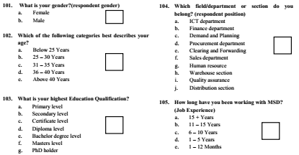

PART II; INFORMATION
For each statement below please circle the appropriate number that best describes level of
agreement or disagreement on the organization.
[Likertscale; Strongly Disagree (1), Disagree (2), Neutral (3), Agree (4), Strongly Agree (5)
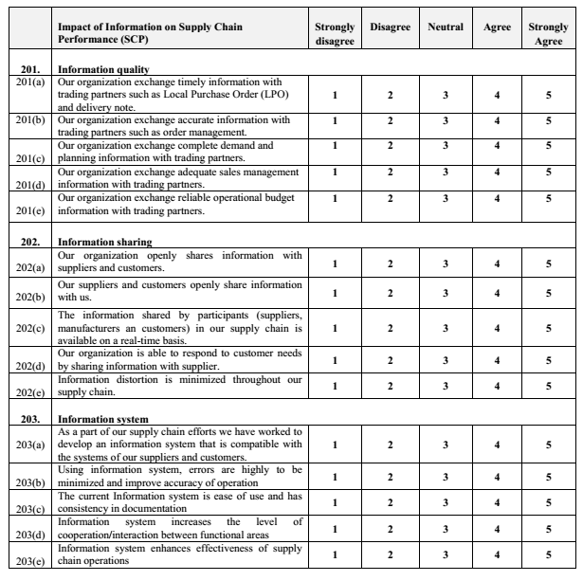

PART III; EMPLOYEES COMPETENCES
For each statement below please circle the appropriate number that best describes level of agreement or disagreement on the organization.
[Likertscale; Strongly Disagree (1), Disagree (2), Neutral (3), Agree (4), Strongly Agree (5)]
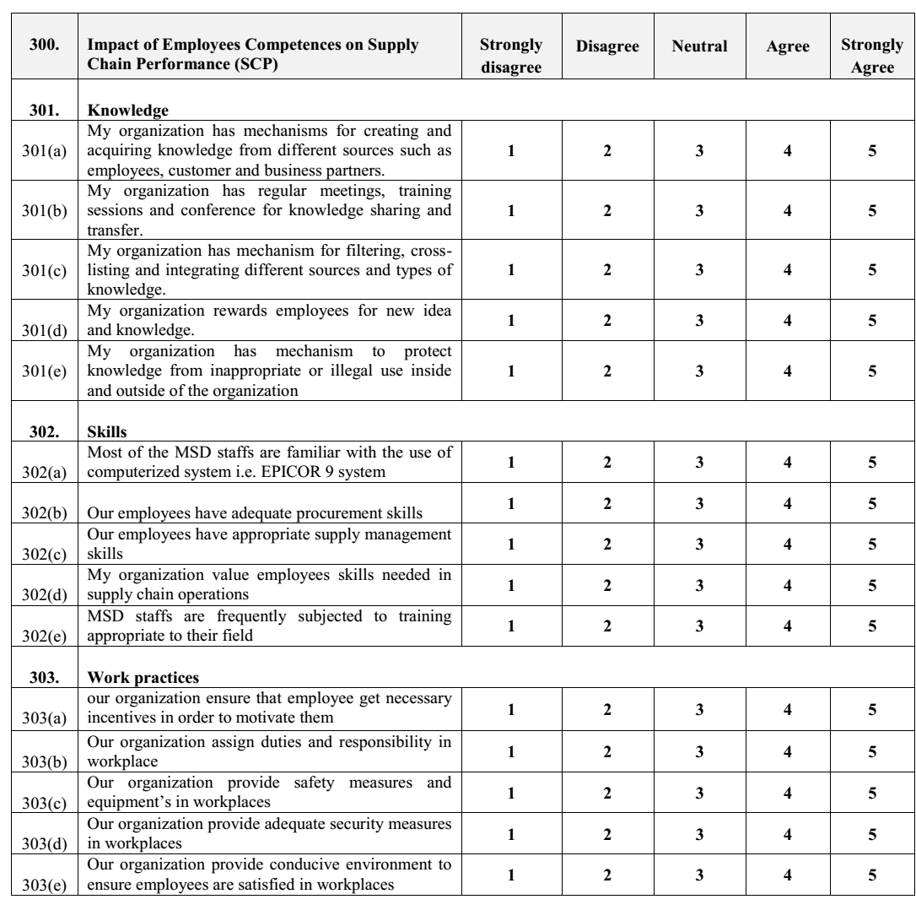

PART IV; TECHNOLOGICAL INFRASTRUCTURE
For each statement below please circle the appropriate number that best describes level of agreement or disagreement on the organization.
[Likert Scale; Strongly Disagree (1), Disagree (2), Neutral (3), Agree (4), Strongly Agree (5)]
